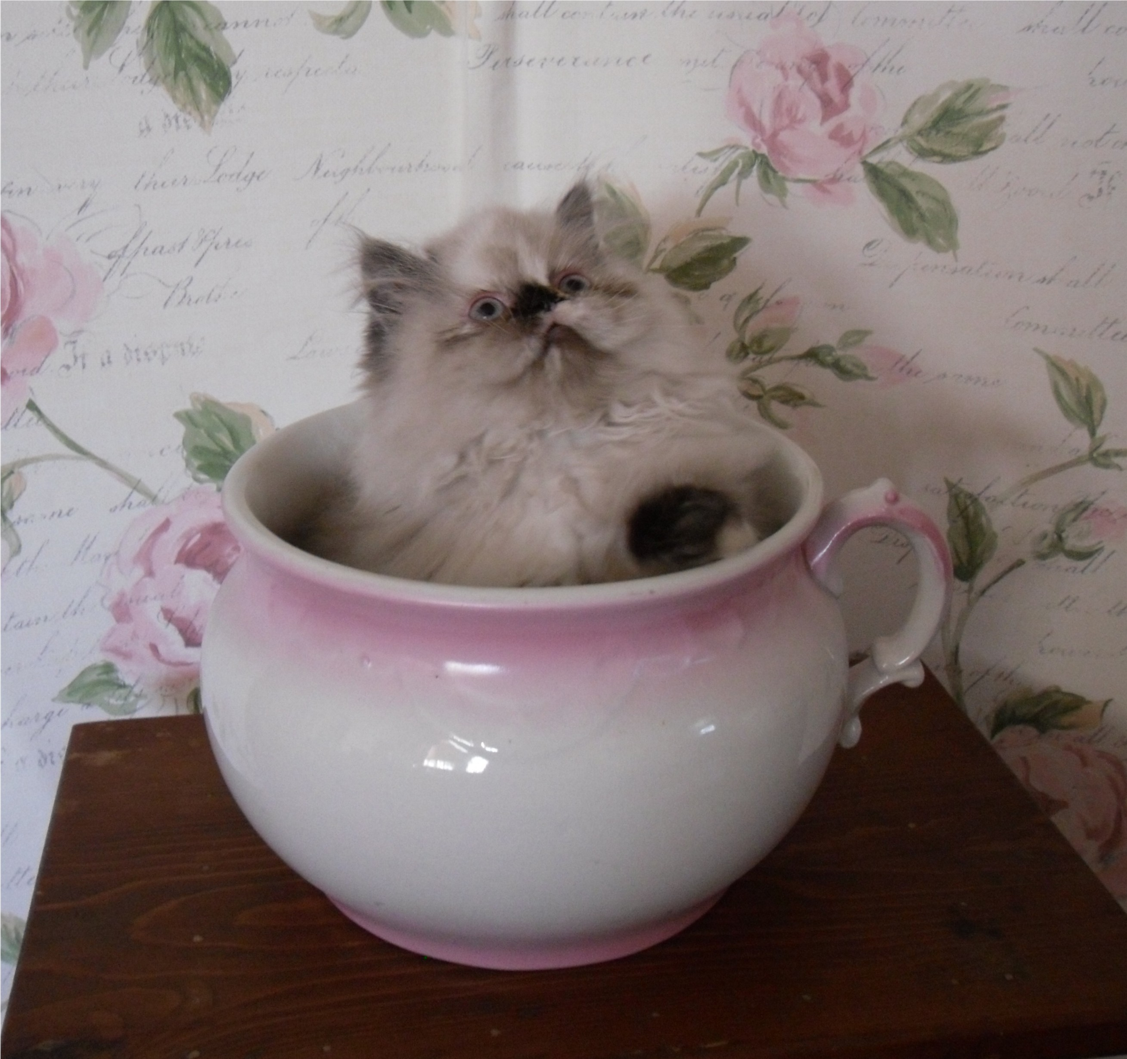

Application for Victorian Gardens Cattery Kitten/Cat

Date:

Legal Name, including those to be listed on Sales Contract:

Home Address:
City:
State:
Zipcode:

Mailing Address:
City:
State:
Zipcode:

Day Phone #:
Evening Phone #:

Email Address:

Name, age, occupation (Company/Title) of each members of household:

Number, name and ages of children in your family:

Do you own or rent your home?:

If renting, do you have written authorization from Landlord to have pets?:

Number, name, type, breed, and ages of pets in your family, including any recently deceased pets:

Your current and past veterinarian’s name/address/phone number:

Please tell us how a Victorian Gardens Cattery kitten/cat will fit into your family and household and what kind of home you would provide for it. Please be as detailed as possible:

What made you be drawn to the Persian and Himalayan breed:

Please tell us what experience you have had with Persians and Himalayans, including any grooming experience:

Are Essential Oils used in the home in any form? Ex: cleaning, diffusers etc.:

What brand and type food are you current feeding your cats:

When would you like a kitten/cat to be added to your family:

Sex of kitten/cat you would prefer:

Type of kitten/cat you would prefer (Persian or Himalayan/ Extreme or Doll Face):

Color of kitten/cat you would prefer:

Are you looking for one or two kittens/cats?

Would you be picking up the kitten/cat or arranging to travel to Cattery for the kitten/cat?

Name of available Victorian Gardens Cattery kitten/cat you are interested in, if applicable:

Would you like to be put on our notification list for future litters?

How did you hear about Victorian Gardens Cattery?

Thank you for considering a Victorian Gardens Cattery kitten/cat

